**Week-3**

Graph-1

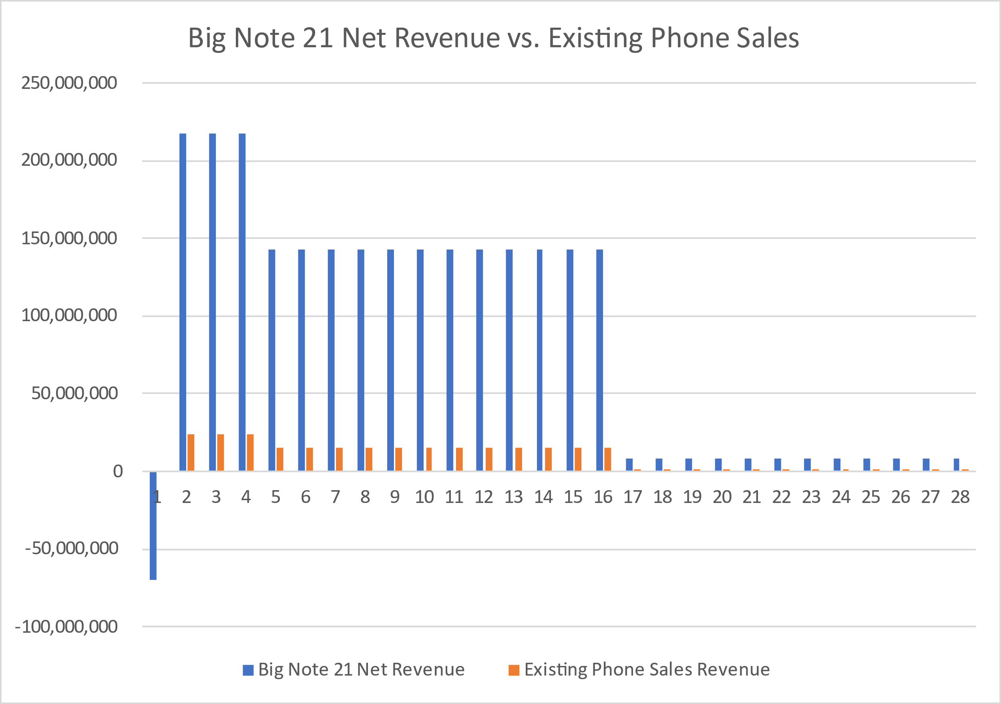

Graph -2

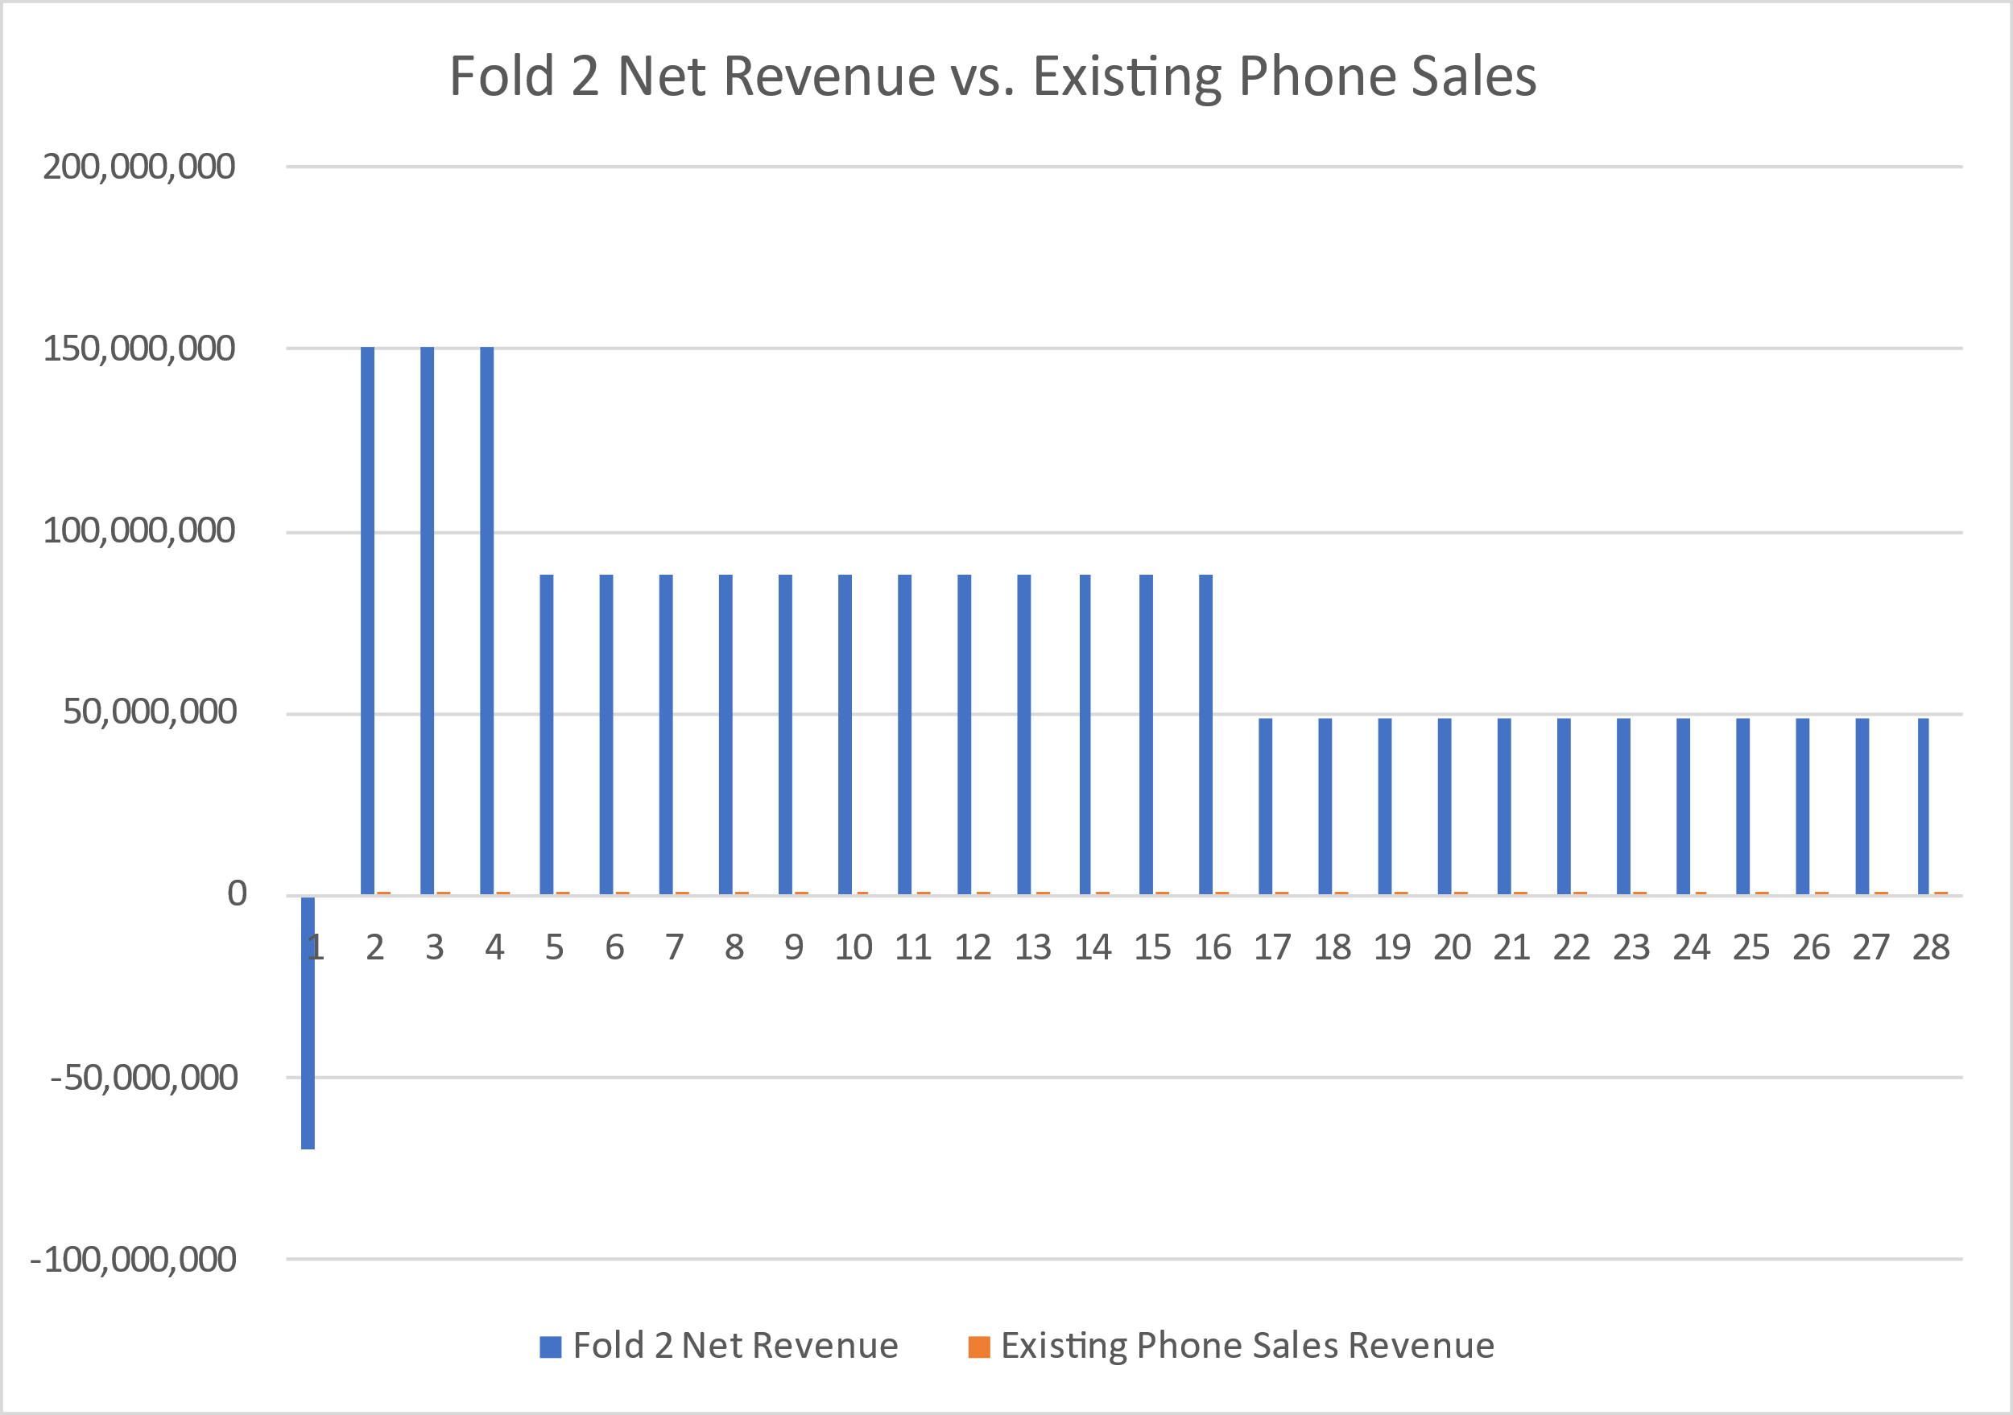

Graph-3

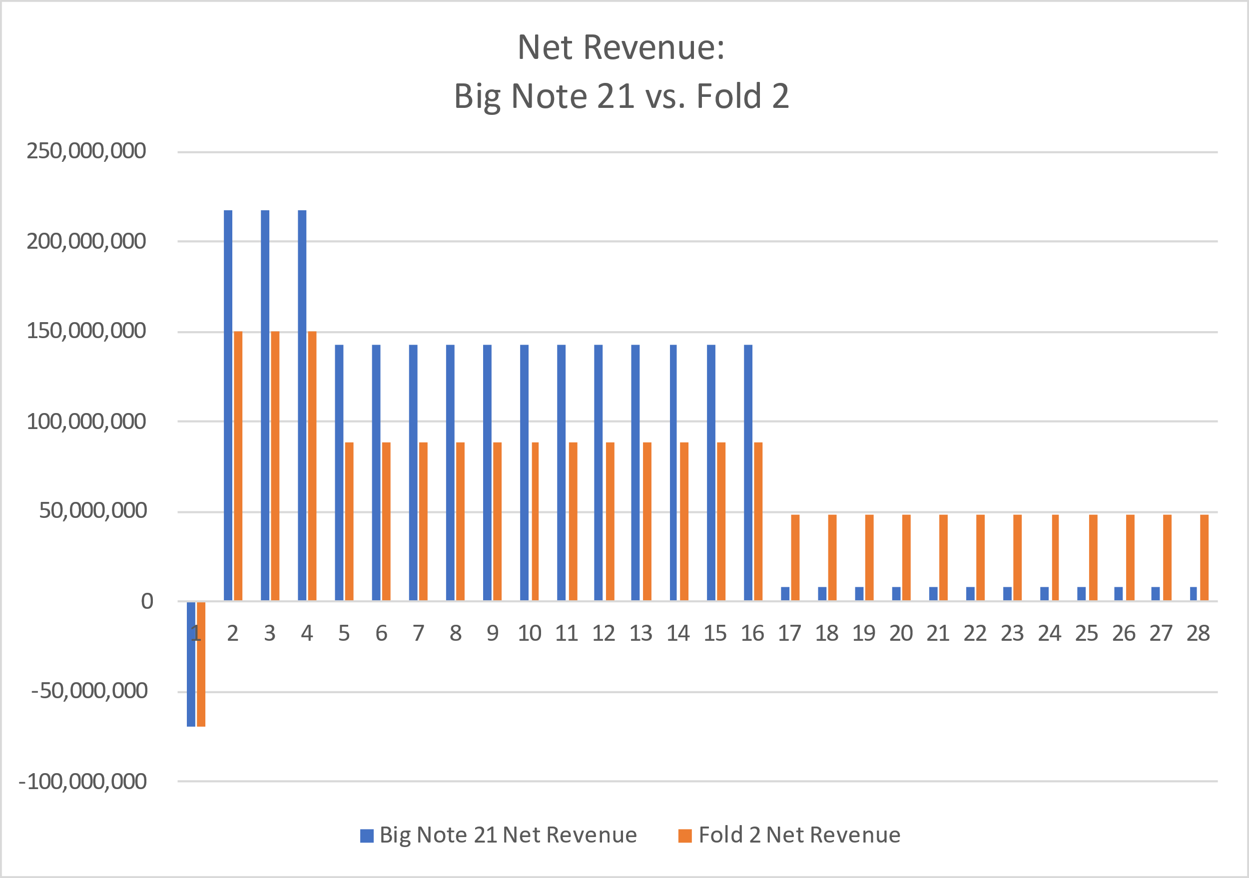

Graph-4

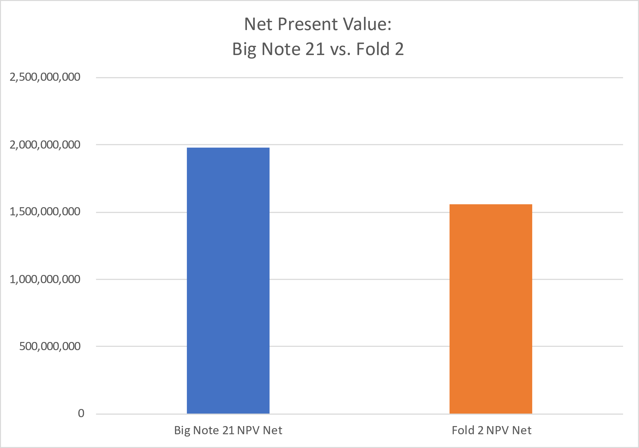

Graph -5

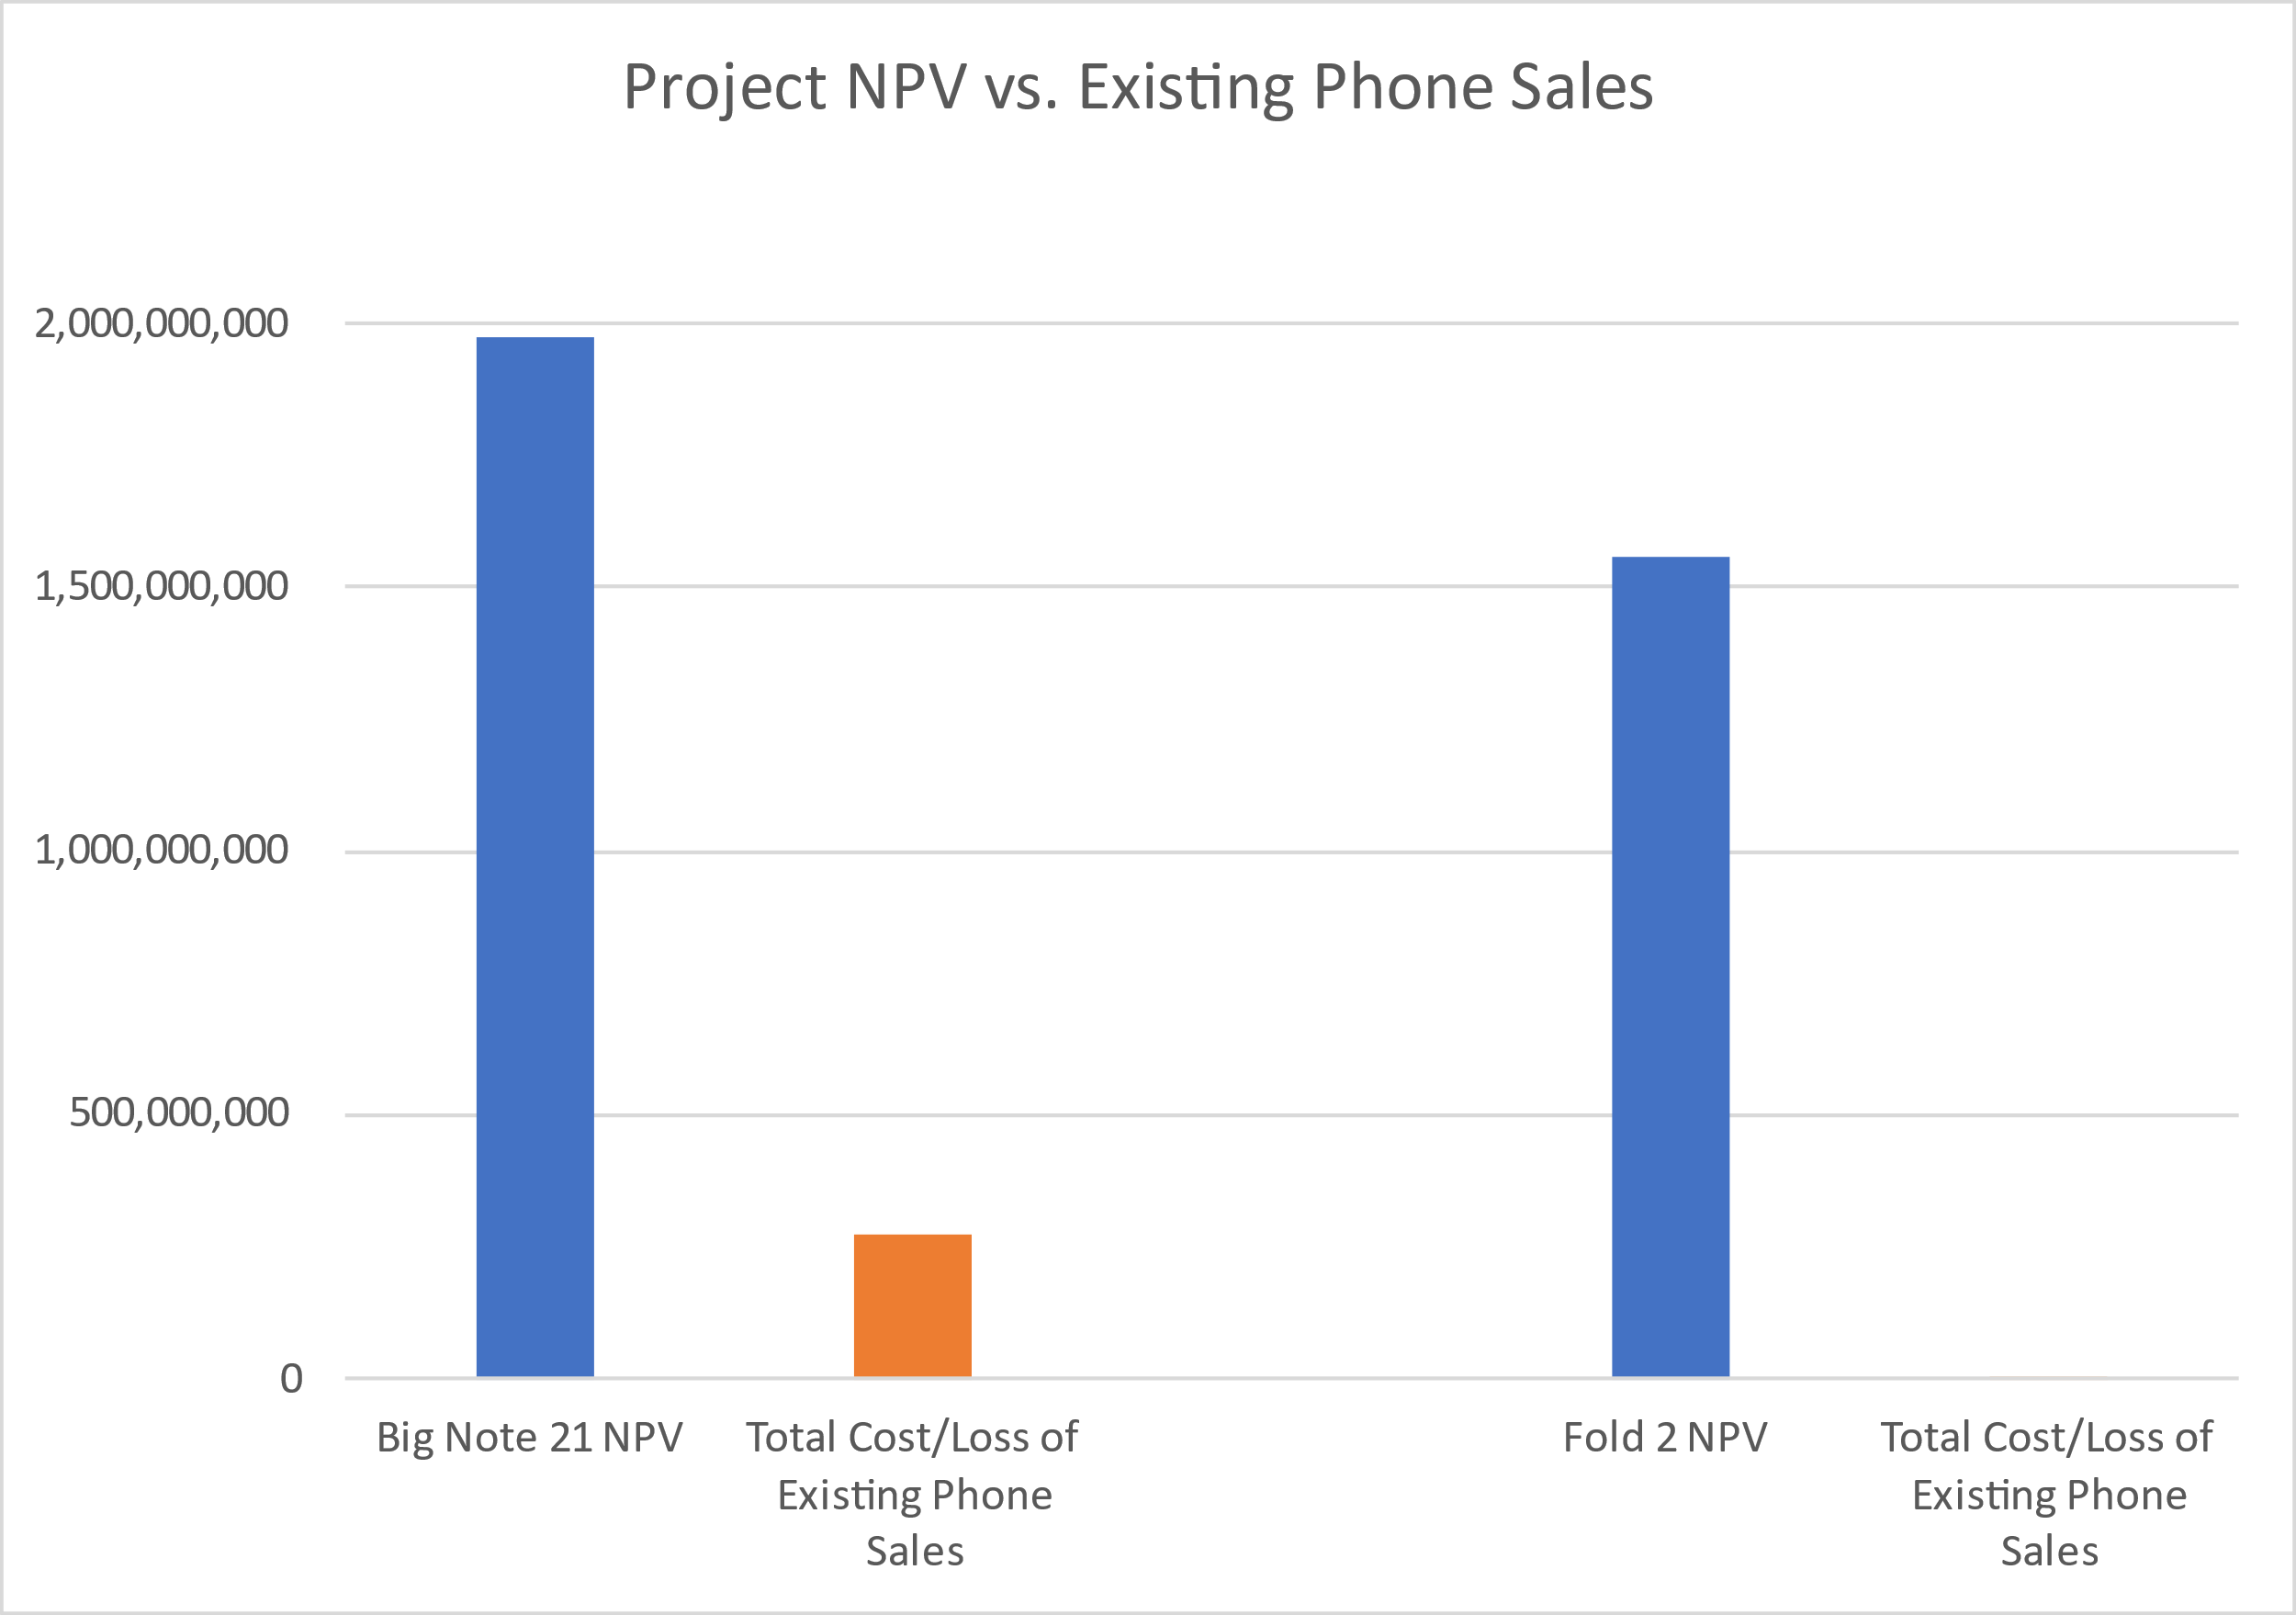

Goal / Task 1:

The task given is to analyze new products for VMobile's investment decisions. Vmobile is about to decide on one of the two product development projects for the new 2021 smartphone line. You need to choose between Project 1 The Big Note 21 and Project 2 The Fold 2. You need to determine and notify the best company CFO for your company. In both projects, the cost of microprocessors, the cost of acquiring camera technology, etc. The one-time cost of the project totals about $ 69,800,000.00. Engineering labor costs were $ 52,056,000.00 over the three periods. The manufacturing cost is about $ 25,920,000.00 for 3 periods, which is the same for both projects. The cost of maintenance over the three periods is $ 5,400,000, which is $ 200,000.00 per month. Qualcomm costs $ 1,000,000.00 per month for consulting. For the first project, net sales for the first three months are $ 662,490,000.00, net sales for the second period are $ 1,753,650,000.00, and net sales for the third period are $ 140,292,000.00. The loss revenue for an existing phone in the first period is $ 71,940,000.00, the loss in the second period is $ 187,020,000.00, and the loss in the third period is $ 15,210,000.00. From this data, you can calculate net sales by subtracting losses from sales that were $ 217,828,400.00 in the first three months, $ 142,991,900.00 in the second period, and $ 8,545,400.00 in the third period. The NPV we found was $ 1,976,257,667.24 and the NPV for existing phones was $ 1,702,087,667.24. For the second project, the total revenue for the first three months is $ 427,286,250.00, the total revenue for the second period is $ 1,019,490,000.00 and the total revenue for the third period is $ 1,019,490,000.00. Project 2's existing phone loss in one period is $ 1,500,000.00, two periods is $ 3,840,000.00, and three periods is $ 1,200,000.00. After removing the loss, net income is $ 150,677,150.00 in the first period, $ 88,186,900.00 in the second period and $ 48,430,400.00 in the third period. The NPV value is $ 1,556,859,384.59 and the net NPV is $ 1,550,319,384.59. In the question, Charts 1 and 2 show the net revenue of the two projects compared to existing phone sales. Graph 3 shows the net profit of both phones. Figure 4 shows the NPV of two phones. Figure 5 is for both the project's NPV and existing telesales.

Suggestions:

We inspire VMobile CEOs to put money into their first project. This is due to the fact the internet sales of the smart phone after the lack of current income become observed to be $ 1,702,087,667.24. Also, if the Big Note 20 is acquainted to humans and those the usage of the Big Note 20 inspire others to shop for our new product, the hazard elements are less. If the smart phone isn't always a massive hit and it takes time for humans to get used to this type of concept, freeing a brand new radical concept may be risky. He says he's aiming for massive income this semester and can not take any dangers at this time. Second, the CEO desires to choose up the smartphone via way of means of the 1/3 region of 2021. So in case you discover issues together along with your Fold 2 telephones and also you do not have time to get them running properly, there's a time constraint.